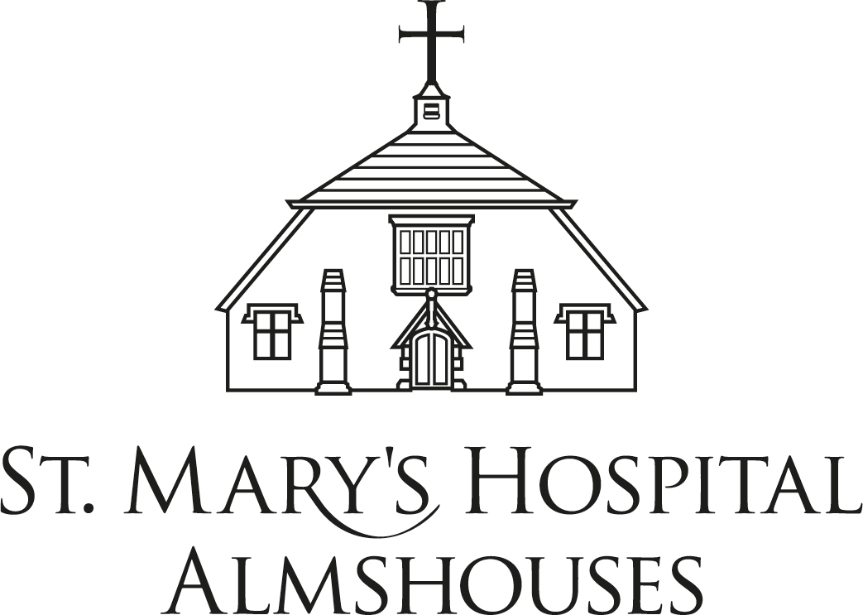

Notes for Prospective Applicants

About the Almshouses
St Mary’s provides 39 almshouses on three sites within Chichester; the original almshouses and Hospital in St Martin’s Square, St Mary’s Lodge in Little London, and the Dears bungalows in Riverside, off St Pancras.
All of our almshouses are self-contained with their own kitchens and bathrooms, most are one-bedroom flats and suitable for single people or in some cases couples. None are suitable for families with children.
The almshouses are managed by a Scheme Manager and Deputy, one of whom is normally on-site during office hours. Residents live independently but may request a daily or weekly call from staff when on site.
A service of Christian worship takes place every weekday in the ancient Hospital chapel which many residents attend. Chapel services are an important part of community life at St Mary’s and Trustees are keen to appoint residents who wish to engage with this.
In a typical year 2 or 3 vacancies arise and these will be offered to applicants who have been approved by Trustees in accordance with the charity’s criteria for appointments which are explained below.

Criteria for Appointment of New Residents
St Mary’s governing document requires prospective residents to be:
- Of good character
- Of limited means
- Resident within the Area of Benefit for five years preceding their application. The area of benefit comprises Chichester and Bognor Regis and any parish within the Diocese of Chichester and within 15 miles of Chichester Cathedral.
When considering applications, further consideration may be given to additional criteria including applicants’:
- Capacity to live independently, look after themselves and maintain their accommodation satisfactorily.
- Financial circumstances and potential capacity to source alternative accommodation options
- Emotional or social vulnerability due to age, health, or disability
- Access to support from extended family
- Interest in engaging with the Christian ethos and spiritual life of the community
- Capacity to contribute to the community life of St. Mary’s.

Application process
Prospective residents are welcome to contact the Scheme Manager or Deputy for an informal discussion before applying.
When completing an application form, which are available from the web site, applicants will be asked to provide detailed information in respect of their:
- Financial circumstances including income and savings.
- Health and ability to live independently.
- Reasons for wishing to move to St Mary’s, as opposed to other options in the social housing sector.
Applicants will need to provide two referees, preferably one of these should be from a Priest or faith group leader. Applications will be assessed and if progressed, a home visit will be arranged.
Applications will be considered by Trustees at meetings which take place quarterly. In rare circumstances, when a vacancy exists, it may be possible to make an offer of accommodation once an application has been accepted. However, in most cases it is likely that applicants who have been accepted will then need to wait for a suitable vacancy to arise.

appointments and Weekly Maintenance Contributions
Prospective residents will be issued with a Letter of Appointment which is the equivalent of a tenancy agreement. This will set out the conditions of residency including payment of the Weekly Maintenance Contributions, which are payable monthly.
Weekly Maintenance Contributions incorporate:
- an accommodation charge which is broadly equivalent to a typical social housing rent and
- a service charge in respect of utility charges which are payable by the charity.

